19 Mar 2021

Eikon CoPrimers (IDMO301-303)

1. ACTB:
   1. 2x Promega MM, 0.15 uM forward and reverse primers, 50 ng hgDNA, and TE buffer.
2. FAM & CR640:
   1. 2x Promega MM, 0.5 uM F & R primers, 50 ng hgDNA, and TE buffer.
   2. The samples with FAM and CR640 share the same reverse primer but have different forward primers.
3. PCR:
   1. 45 cycles
   2. 95 °C for 1 sec
   3. 55 °C for 30 sec

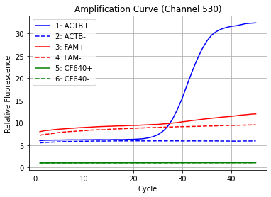

Channel 530

ACTB+ showed the strongest signal in this channel with little to no signal from the other samples

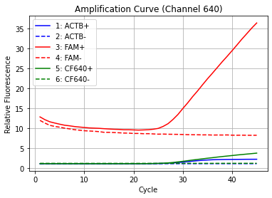

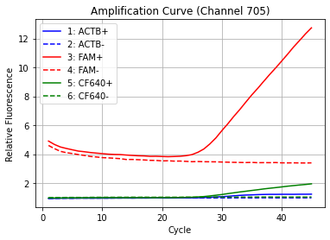

Channels 640 & 705

In these two channels, the FAM+ sample showed the strongest signal and CF640+ starts to show a weak signal as well.